

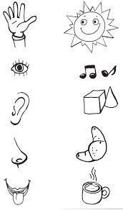

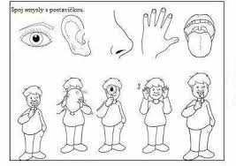

[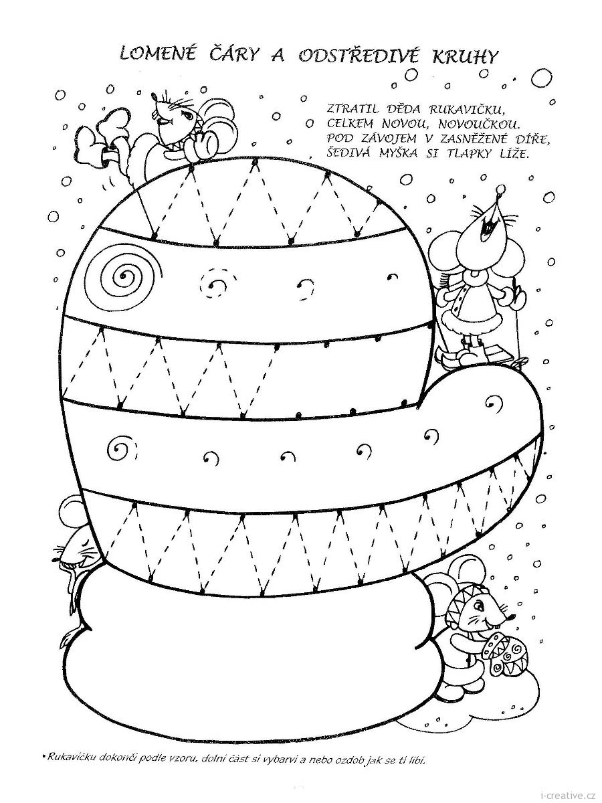](https://www.google.com/url?sa=i&url=https%3A%2F%2Fwww.chabarovicka.cz%2Fzluta_skolka_do_skolka%2F&psig=AOvVaw0Ve3C_SrDDCU8LNWcMpNvt&ust=1612003856318000&source=images&cd=vfe&ved=0CAIQjRxqFwoTCIjiwsL-wO4CFQAAAAAdAAAAABAE)

[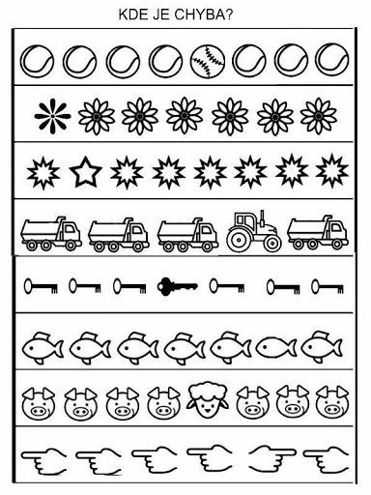](https://www.google.com/url?sa=i&url=http%3A%2F%2Fwww.ms-vsetickova.cz%2Finspirace-pro-deti-a-rodice-v-dobe-uzavreni-ms%2F&psig=AOvVaw0Ve3C_SrDDCU8LNWcMpNvt&ust=1612003856318000&source=images&cd=vfe&ved=0CAIQjRxqFwoTCIjiwsL-wO4CFQAAAAAdAAAAABAL)